**DIT5401**

**Internet & Web Publishing**

*Trimester 2, Session 2022 / 2023*

Project Title:

BY

|  |  |  |
| --- | --- | --- |
| **No.** | **Student ID** | **Student Name** |
|  | 1221101850 | TAN KIM HIAN |
|  | 1221201009 | WONG YAN SHENG |
|  | 1221101250 | LIM SAI MAN |
|  | 1221201013 | KOH SOON KEAT |

Table of Contents

**TABLE OF CONTENTS 1**

**TASK DISTRIBUTION FORM 2**

**PROJECT EVALUATION FORM 3-4**

**PART 1: INTRODUCTION 5**

**PART 2: OBJECTIVE OF THE WEBSITE 6**

**PART 3: TARGET USER 7**

**PART 4: SCREENSHOTS OF THE WEBPAGE 8**

**REFERENCES 9**

**APPENDIX (Meeting Minutes) 10**

**TASK DISTRIBUTION FORM**

|  |  |  |  |  |
| --- | --- | --- | --- | --- |
| **No.** | **Student ID** | **Student Name** | **Tasks Completed** | **Signature** |
|  | 1221101850 | TAN KIM HIAN | * User Page HTML and CSS. * User Home Page * Feedback and Contact Page * Buy and Rent Page * User Login Page * Find Agent Page * T&S and Policy Page |  |
|  | 1221201009 | WONG YAN SHENG | * Admin Page HTML and CSS. * Admin Home Page * Sales Report Page * Agent and Customer List * Admin Login Page * Admin Marketplace Page * About Us Page |  |
|  | 1221101250 | LIM SAI MAN | * Agent Page HTML and CSS. * Agent Home Page * Choice Page * Sales Report Page * Agent Profile Page * Customer and Marketplace Page * Edit Profile and Booking Page. |  |
|  | 1221201013 | KOH SOON KEAT | * User Page HTML and CSS. * User Payment Page * Image Review Page * Comment and Review Page * User Posting Page |  |

**DIT5401 Internet & Web Publishing**

**PROJECT EVALUATION FORM**

|  |  |  |  |
| --- | --- | --- | --- |
| **STUDENT ID** | **STUDENT NAME** | **Peer Evaluation Total Marks (20M)**  **(For Evaluator Use)** | **Project**  **(For Evaluator Use)**  **(40M)** |
| **1221101850** | **TAN KIM HIAN** |  |  |
| **1221201009** | **WONG YAN SHENG** |  |  |
| **1221101250** | **LIM SAI MAN** |  |  |
| **1221201013** | **KOH SOON KEAT** |  |  |
|  |  |  |  |
|  |  |  |  |

|  |  |  |  |  |  |  |  |  |  |
| --- | --- | --- | --- | --- | --- | --- | --- | --- | --- |
| **1** | **Very Poor** | **2** | **Poor** | **3** | **Average** | **4** | **Good** | **5** | **Excellent** |

**WEBSITE:**

|  |  |  |
| --- | --- | --- |
| **Criteria** | **Marks** | **Comments/ Remarks** |
| 1. Content (User/Customer)  * Content relevance, appropriateness, organization and presentation |  |  |
| 1. Content (Administrator):  * Content relevance, appropriateness, organization and presentation |  |  |
| 1. Graphics & CSS |  |  |
| 1. Hyperlinks |  |  |
| 1. Form |  |  |
| 1. Multimedia elements |  |  |
| 1. Extra features (responsive element, javascript) |  |  |
| 1. Overall design |  |  |
| **Total (40)** |  |  |

**REPORT:**

|  |  |  |
| --- | --- | --- |
| **Criteria** | **Marks** | **Comments/ Remarks** |
| * Checklist & Evaluation Form | /2 |  |
| * Task distribution | /2 |  |
| * Objective/Purpose | /2 |  |
| * Target User | /2 |  |
| * Screenshot of website | /10 |  |
| 1. Cover page completed | /1 |  |
| 1. Header, Page number and title numbering are included | /1 |  |
| **Total (20)** |  |  |

**PRESENTATION:**

|  |  |  |
| --- | --- | --- |
| **Criteria** | **Marks** | **Comments/ Remarks** |
| * Clarity of speaking | /3 |  |
| * Understanding of the website | /4 |  |
| * Presenter’s appearance (formality, professionalism) | /3 |  |
| **Total (10)** |  |  |

**PART 1: INTRODUCTION**

This section describes the topic selection and explain/list the web pages that you have developed.

In this era where the digital landscape has seamlessly woven itself into our daily lives, the real estate industry has undergone a transformative journey. So, we have decided to create a property related website. Our website allows us to explore the convergence of technology and property, giving rise to a dynamic and comprehensive property website.

We aim to dissect the intricacies of our digital creation, offering a glimpse into the fusion of property and the online sphere. In this assignment, we have created three distinct roles that are agent, admin, and user for people to explore how it looks like from all three different perspectives.

First and foremost, we created a page for welcoming you onto our website that allows you to choose your role. For the Agent page, we have created an Agent Login page, Agent Register Page, Agent home page, Agent Edit Profile Page, Agent Customer List Page, Agent Booking Page, Agent Marketplace Page, Agent Profile Page, Agent Posting Page, and Agent Sales Page.

Besides, for the User Page,

**PART 2: OBJECTIVE/PURPOSE OF THE WEBSITE**

Our website aims to make your search for homes and properties easy and enjoyable. Whether you're buying, selling, or just exploring, we want to provide a seamless experience. We've carefully considered three main groups - the individuals selling homes (known as Agents), the behind-the-scenes folks managing everything (Admins), and, of course, you, the person searching for that perfect place to call home (Users).

For Agents, we've equipped the platform with tools to simplify their work. They can effortlessly showcase properties, communicate with clients, and manage transactions. Admins have their own set of tools to ensure everything runs smoothly, maintaining the website's security and optimal functionality.

Ensuring a safe and secure environment for your home transactions is a top priority for us. Our website incorporates cutting-edge security measures to safeguard your information. We also aim to present you with a diverse range of properties, providing ample options for your consideration. The website is designed to evolve with emerging technology and your evolving needs.

Hence, we leverage innovative technologies, allowing agents to post videos and photos to enhance the experience of your property search. Beyond the business aspect, our website is a treasure trove of guides and information to improve your understanding of the real estate landscape.

In short, our property website is dedicated to making real estate simple, secure, and even a bit enjoyable. It's more than just a website; think of it as a friendly guide assisting you in finding your dream home in the ever-evolving world of digital real estate.

**PART 3: SCREENSHOTS OF WEBPAGE**

**Agent Sided Page:**

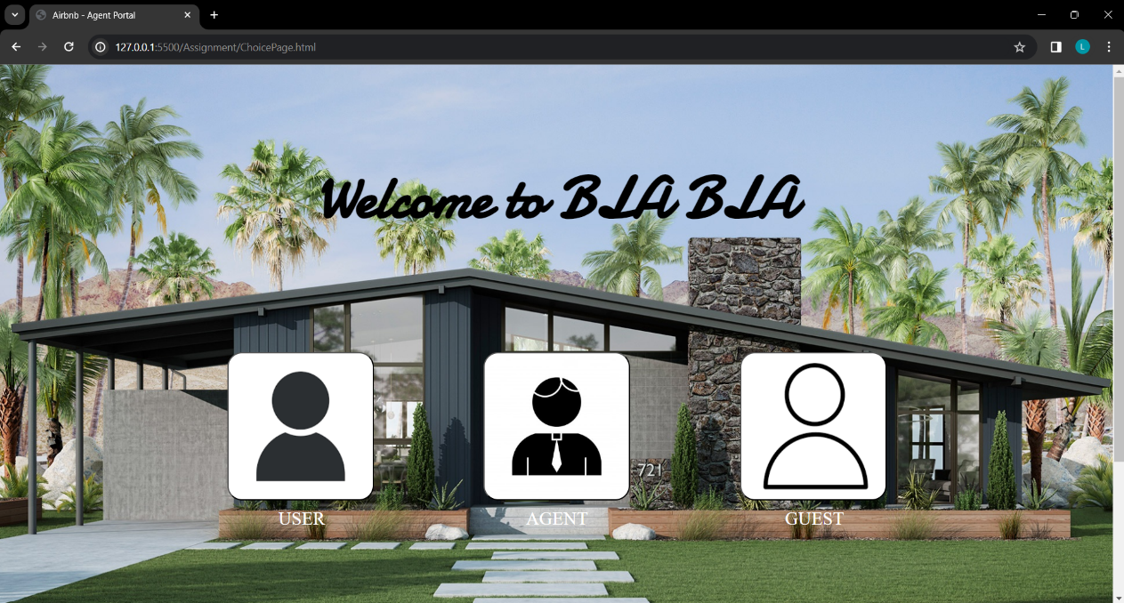

***Figure 1.*** *Choice Page*

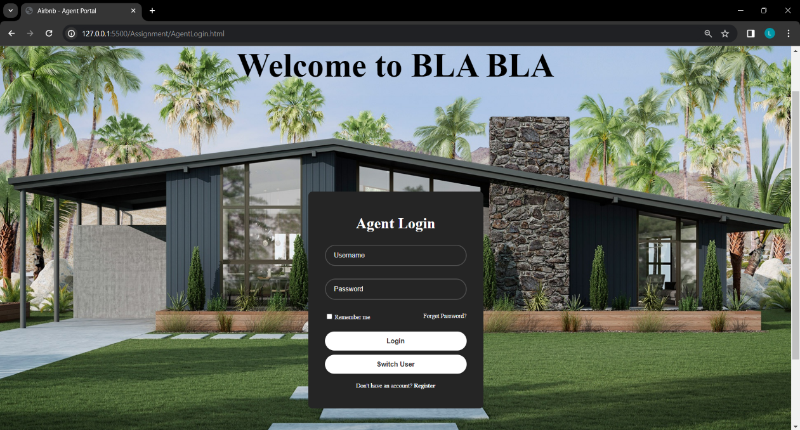

***Figure 2.*** *Agent Login Page*

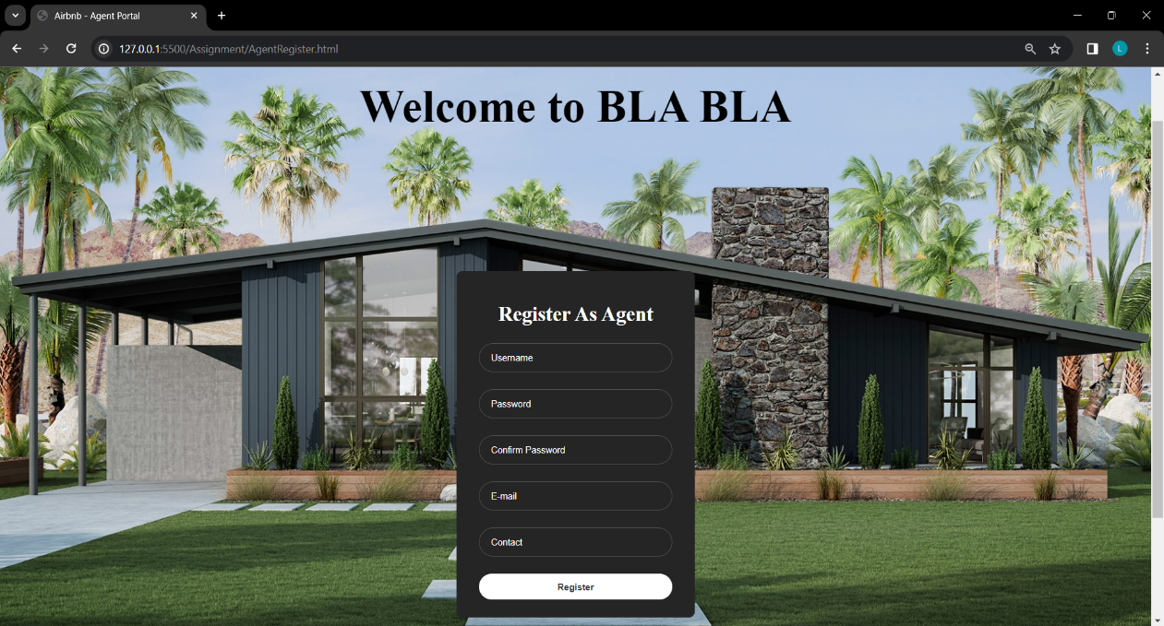

***Figure 3.*** *Agent Register Page*

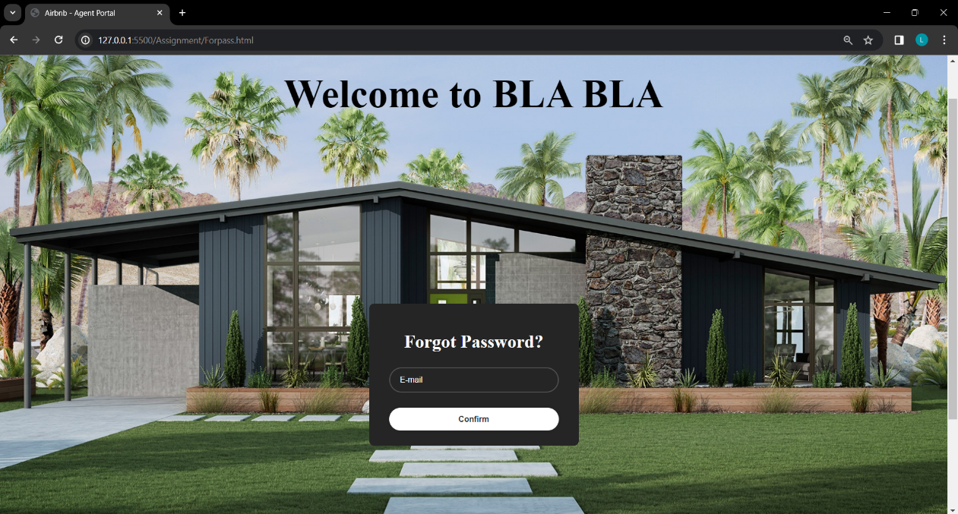

***Figure 4.*** *Agent Forget Password Page*

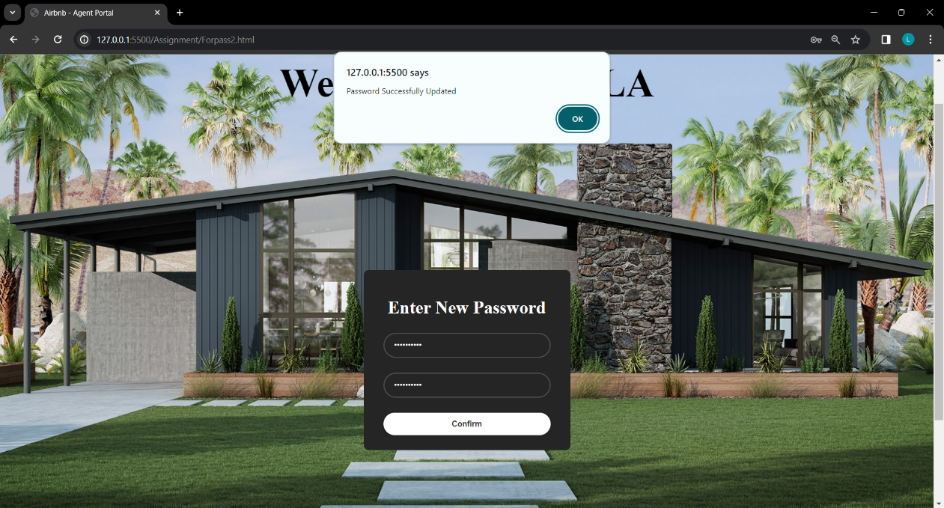

***Figure 5.*** *Enter New Password Page*

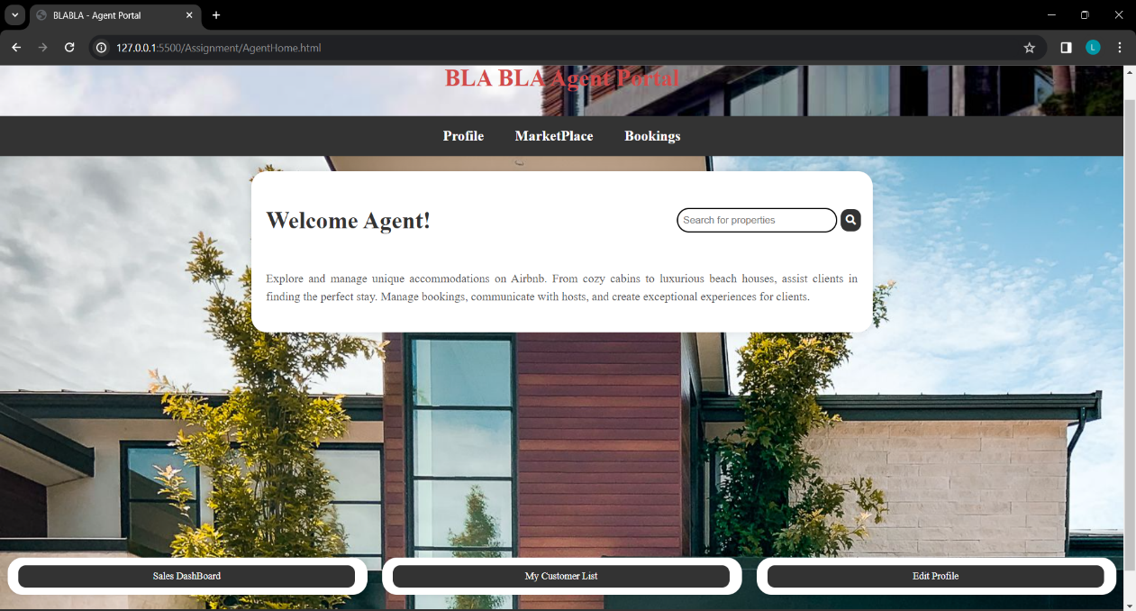

***Figure 6.*** *Agent Main Page*

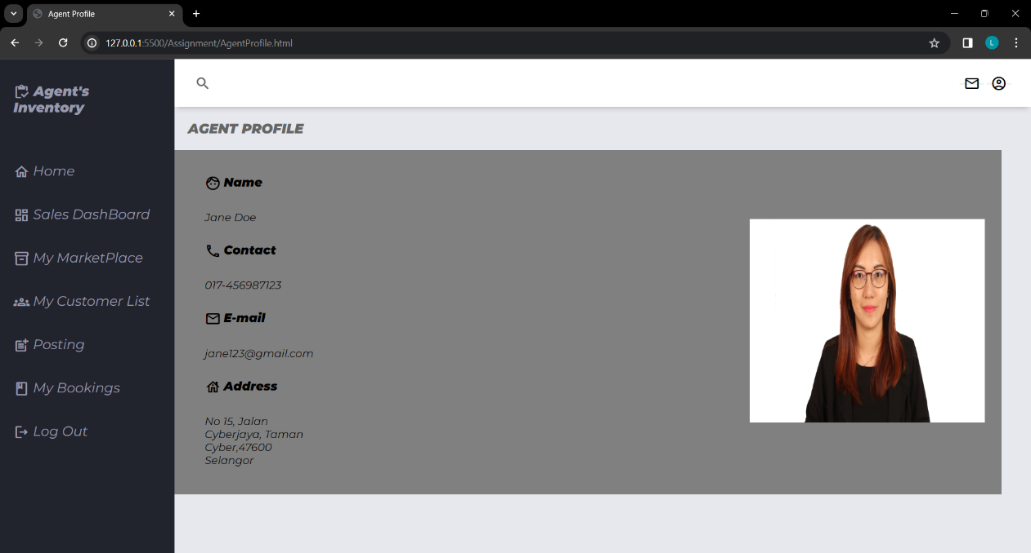

***Figure 7.*** *Agent Profile Page*

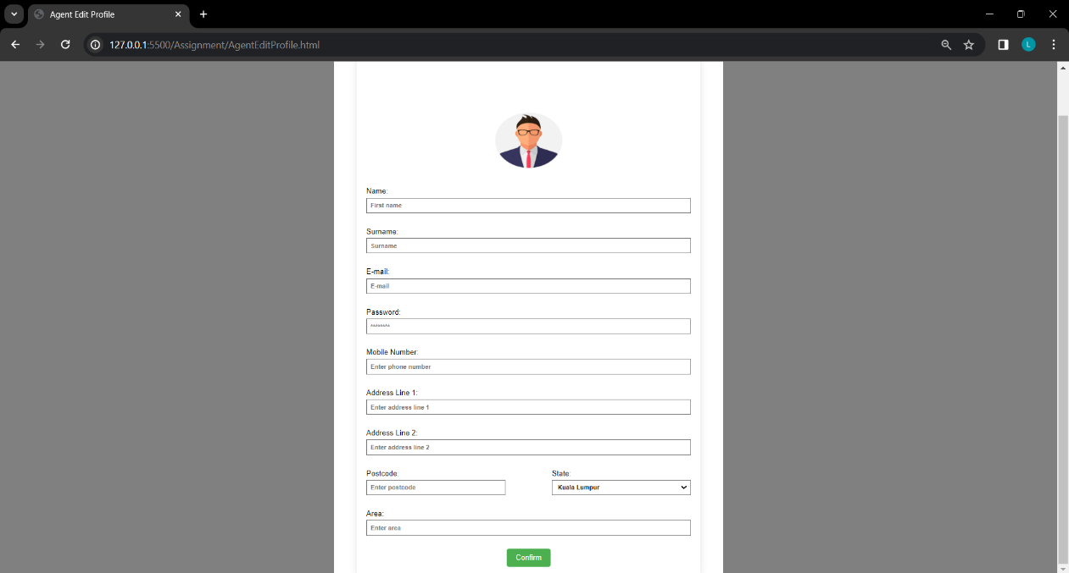

***Figure 8.*** *Agent Edit Profile Page*

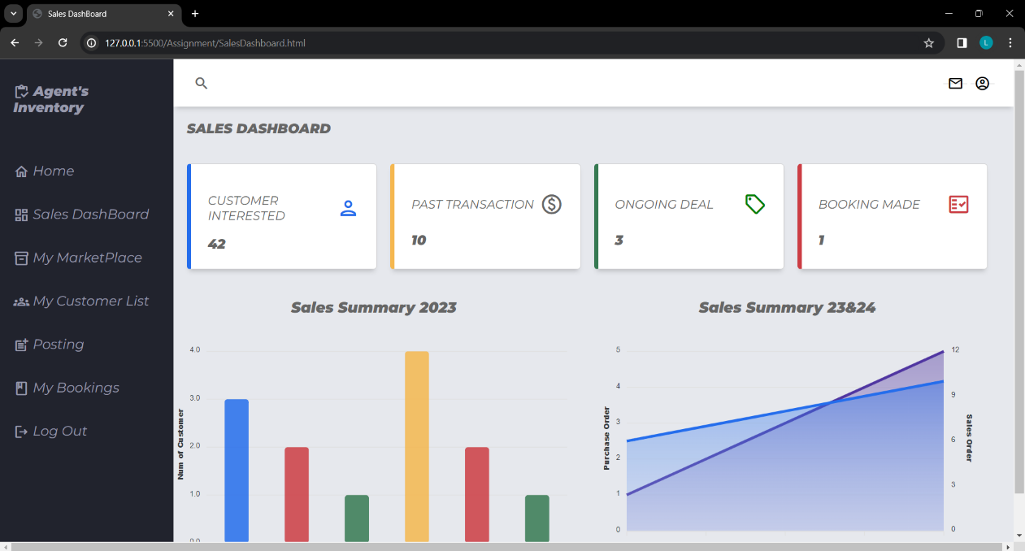

***Figure 9.*** *Agent Sales Dashboard Page*

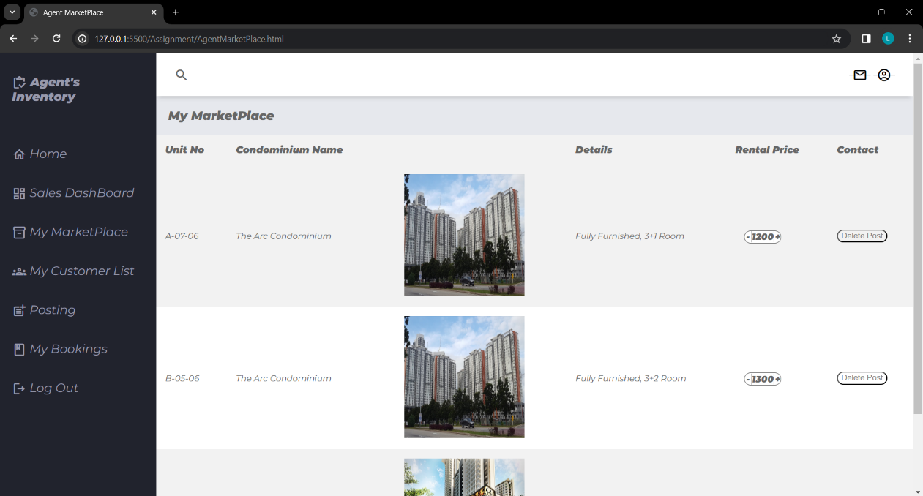

***Figure 10.*** *Agent Own Marketplace Page*

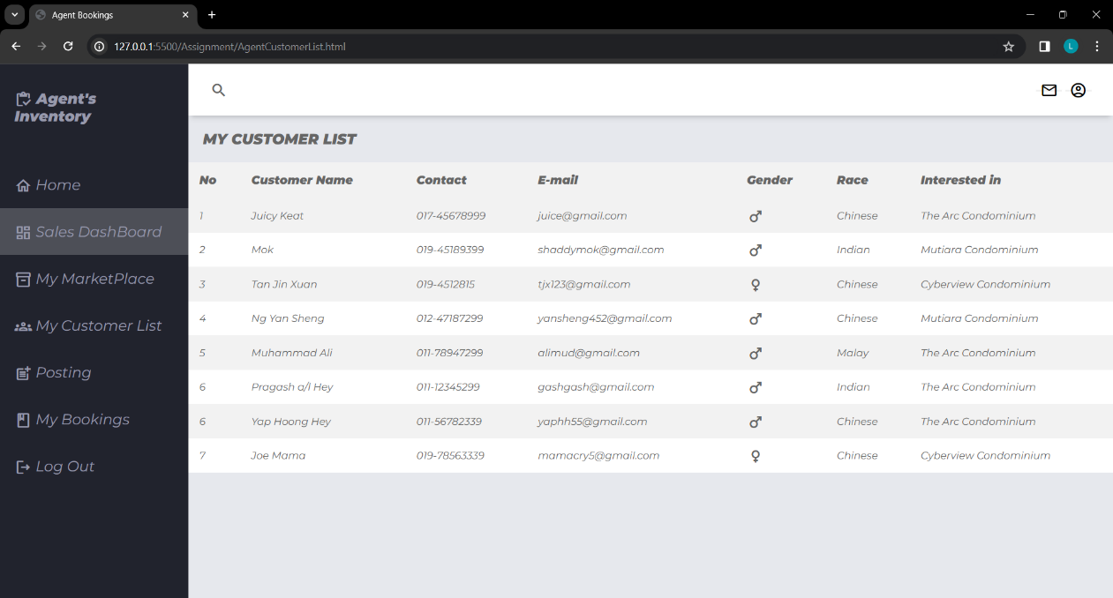

***Figure 11.*** *Agent Customer List Page*

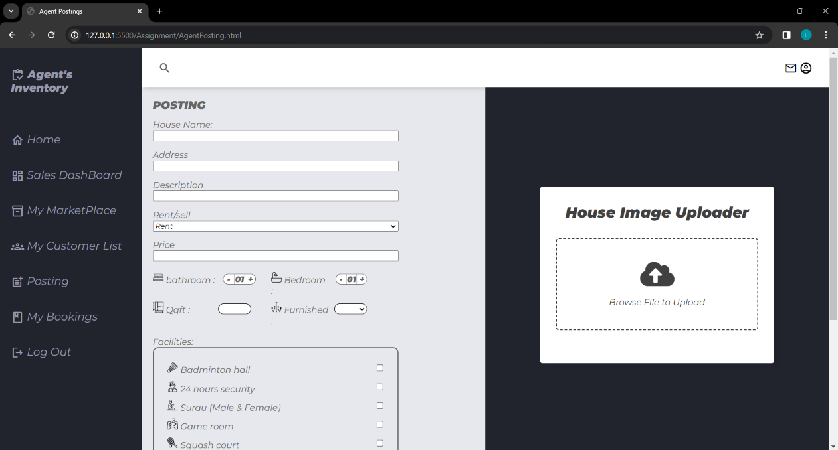

***Figure 12.*** *Agent Posting Page*

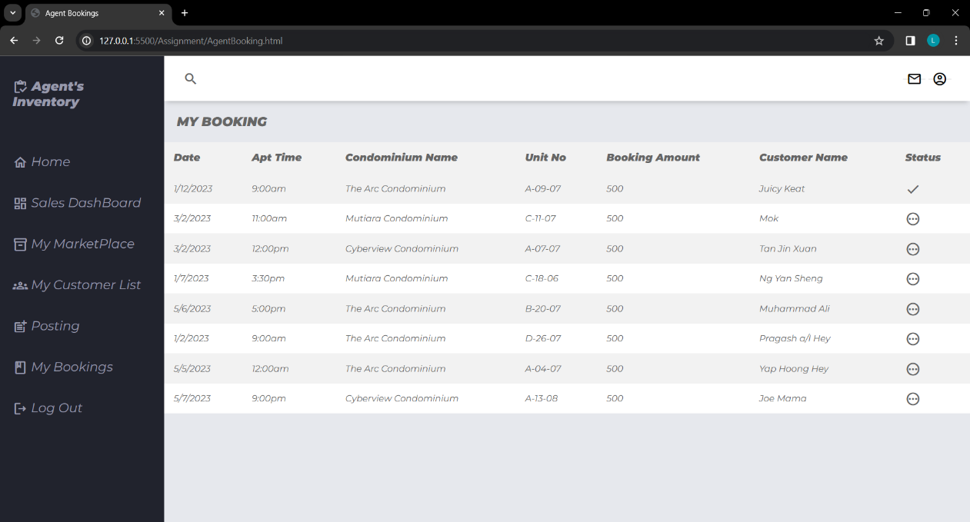

***Figure 13.*** *Agent Booking Page*

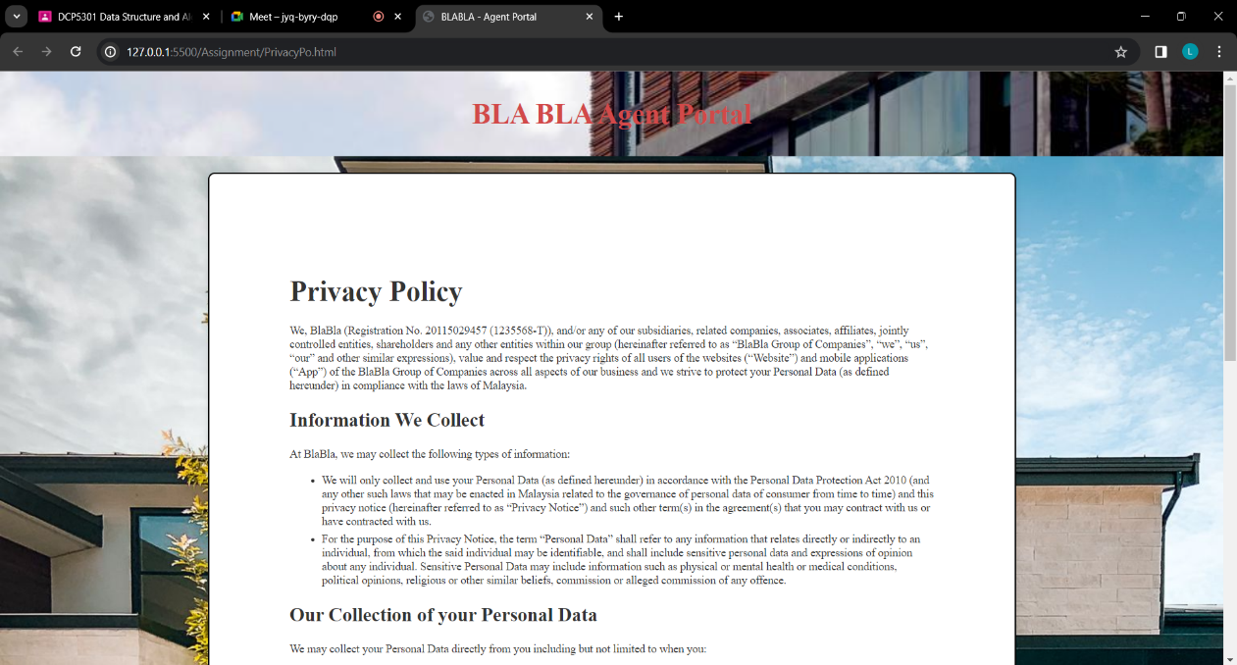

***Figure 14.*** *Policy Page*

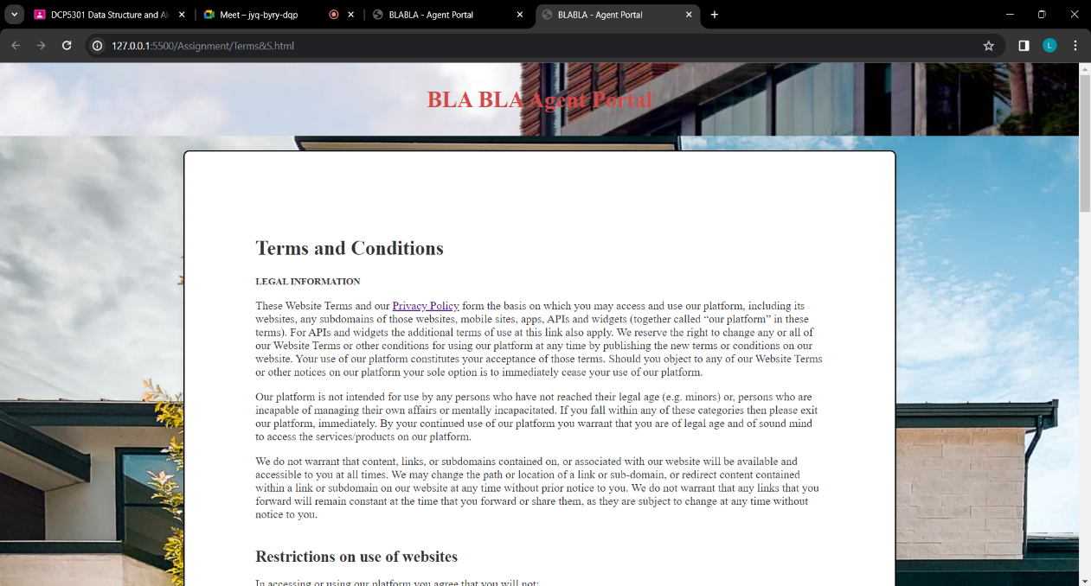

***Figure 15.*** *Terms & Conditions Page*

**Admin Sided Page:**

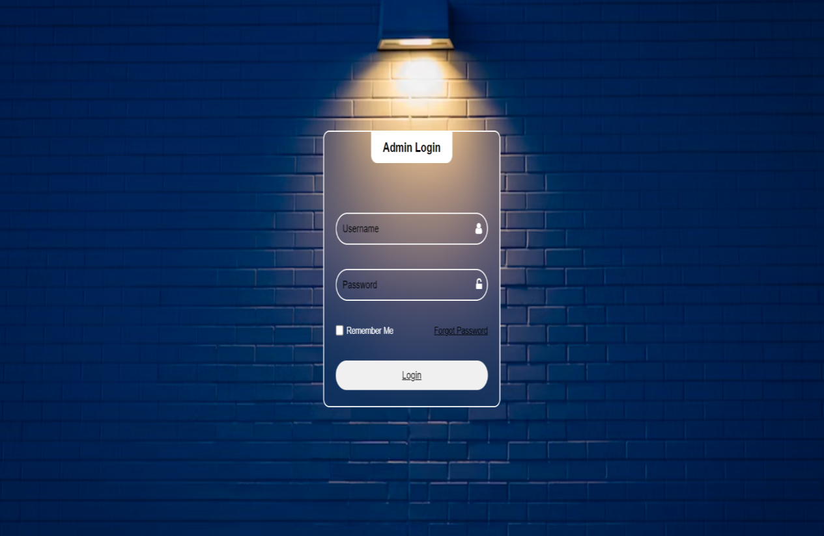

***Figure 16.*** *Admin Login Page*

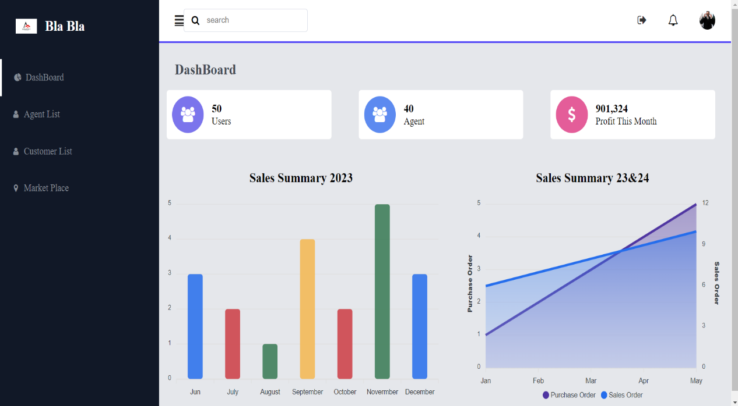

***Figure 17.*** *Admin Dashboard Page*

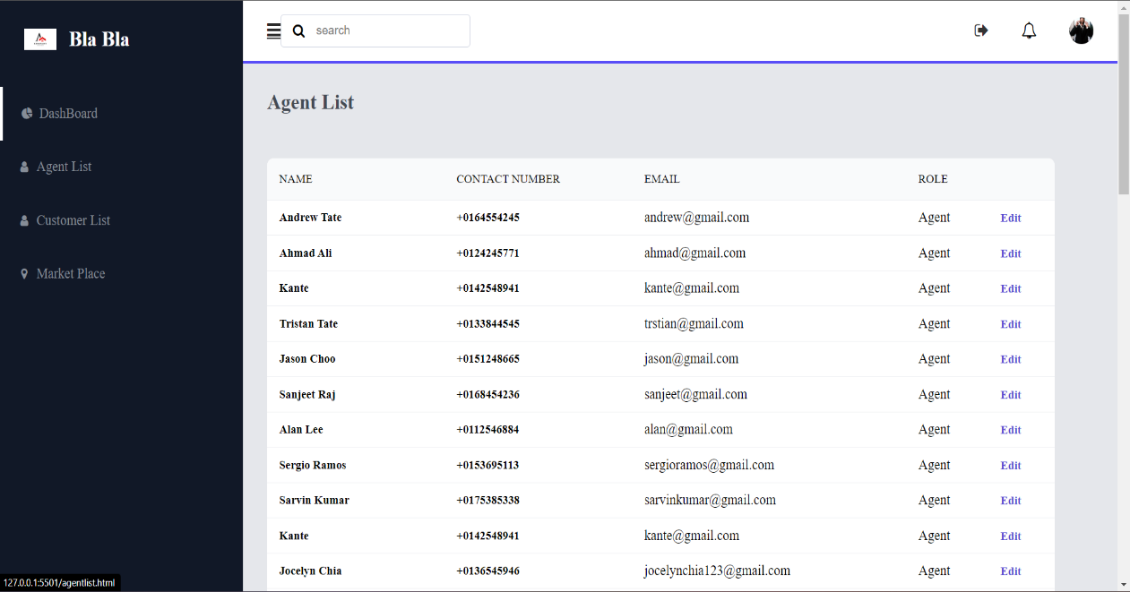

***Figure 18.*** *Admin Agent List Page*

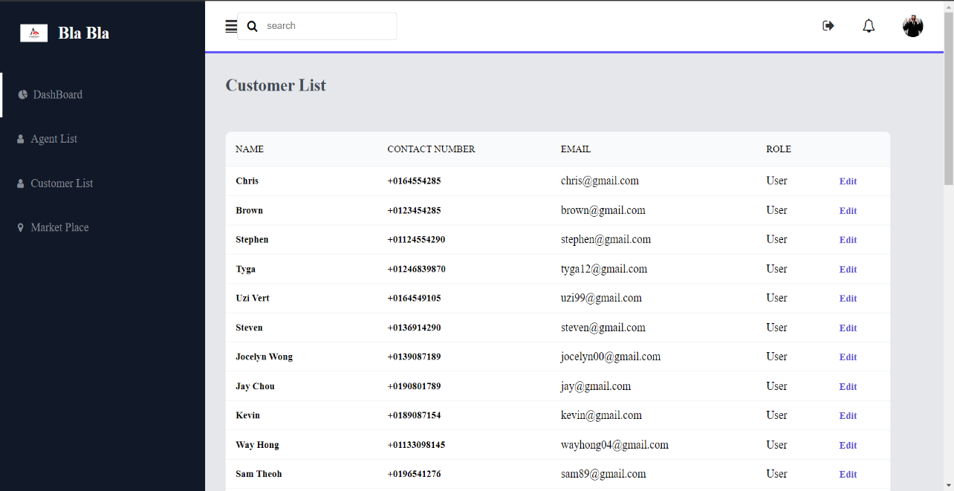

***Figure 19.*** *Admin Customer List Page*

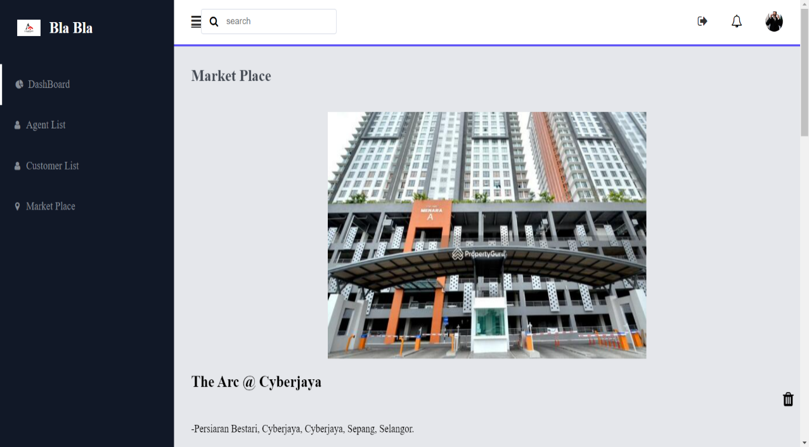

***Figure 20.*** *Admin Marketplace Page*

**User Sided Page:**

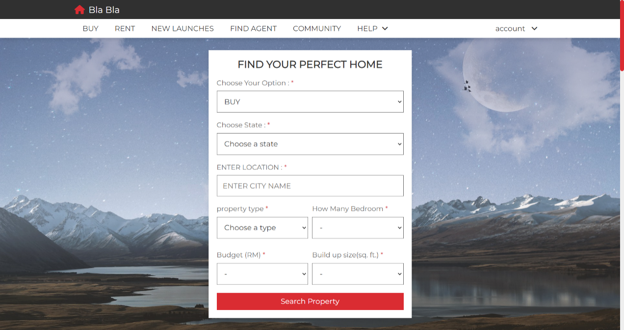

Figure 21. User Home Page (Part 1)

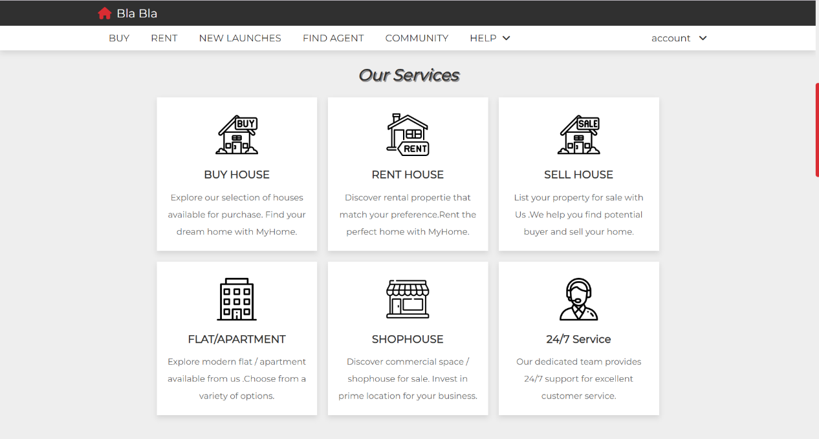

Figure 22. User Home Page (Part 2)

aa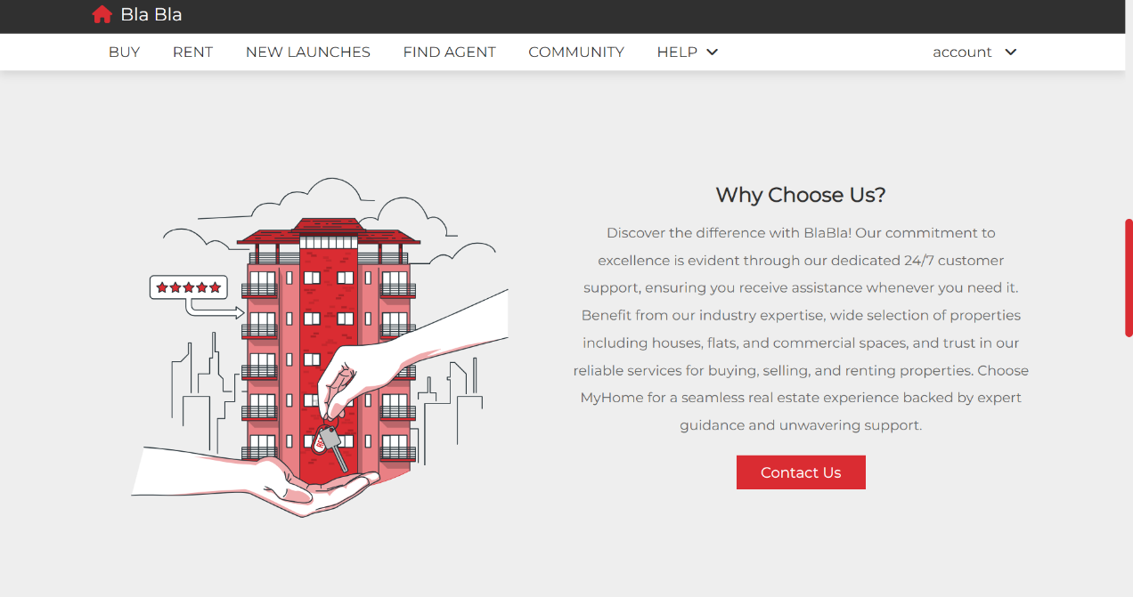

Figure 23. User Home Page (Part 3)

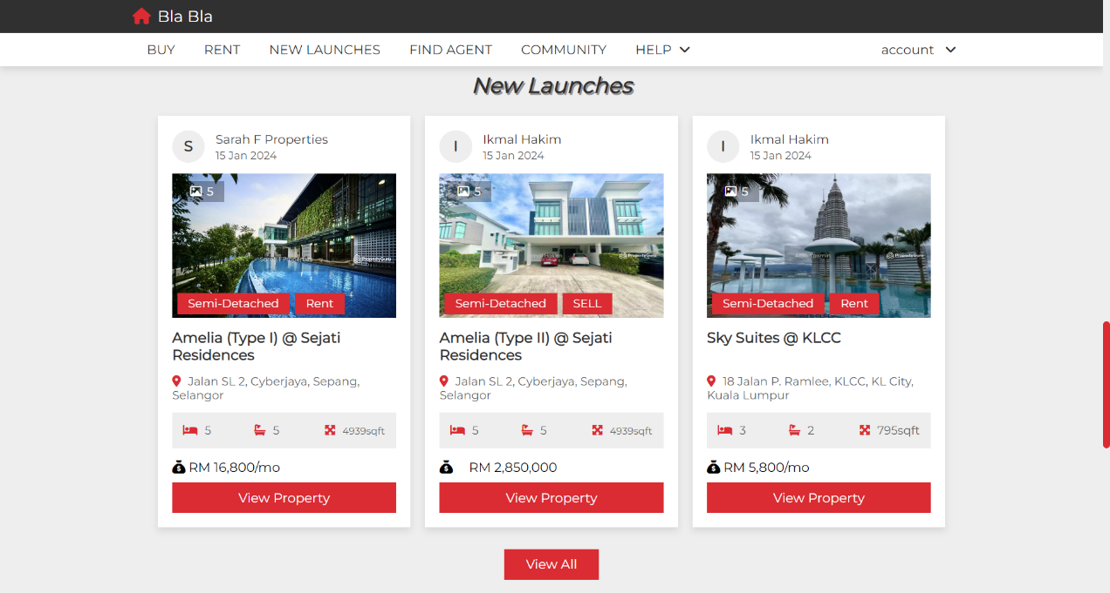

Figure 24. User Home Page (Part 4)

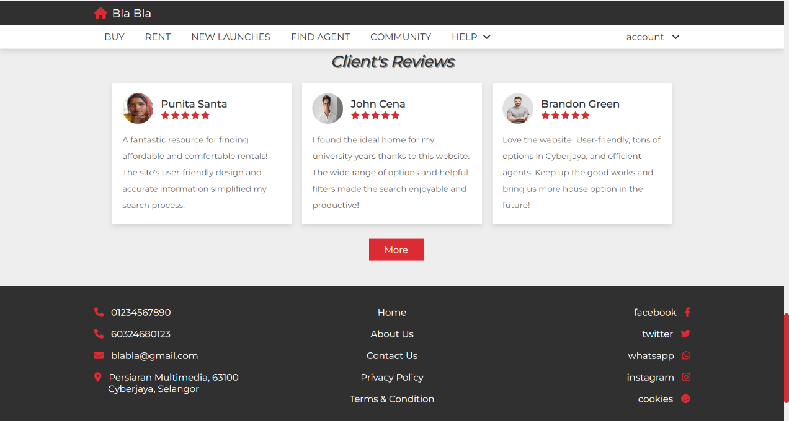

Figure 25. User Home Page (Part 5)

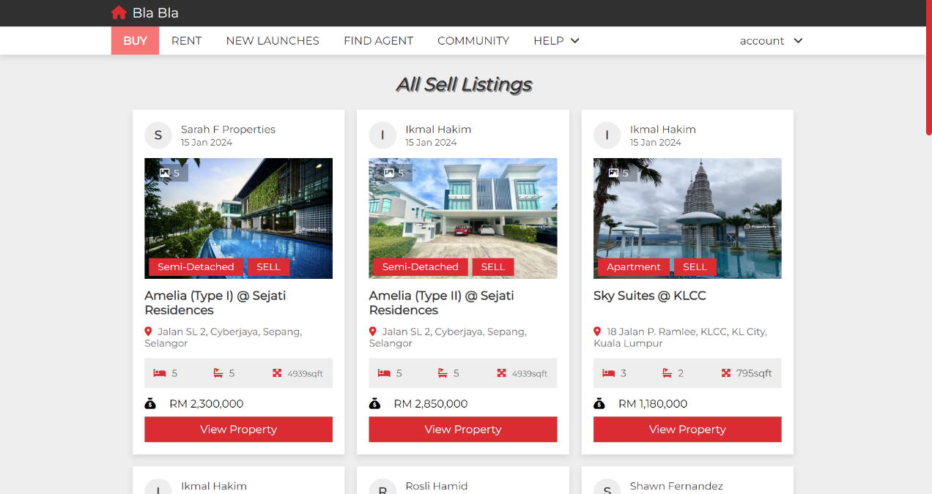

Figure 26. User Buy Page (Part 1)

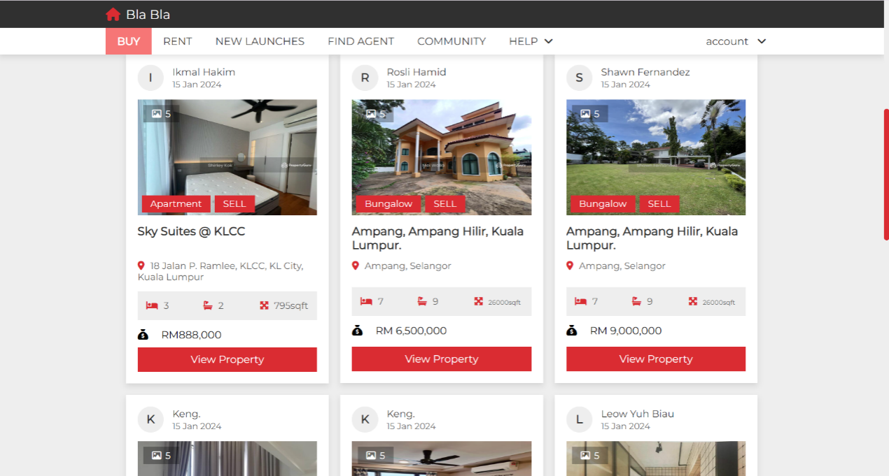

Figure 27. User Buy Page ( Part 2 )

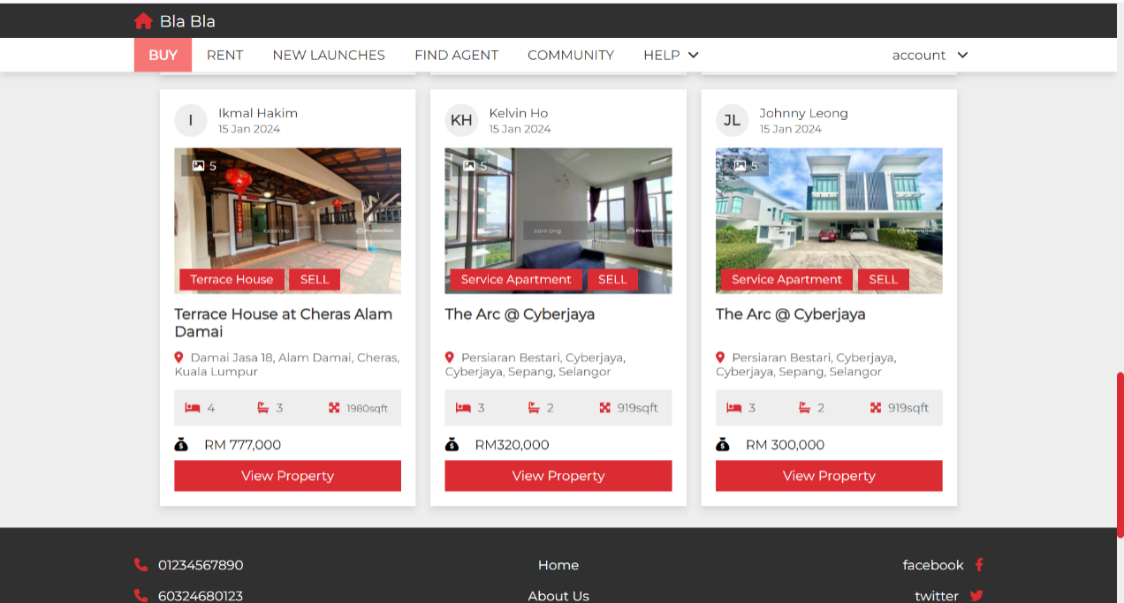

Figure 28. User Buy Page ( Part 3)

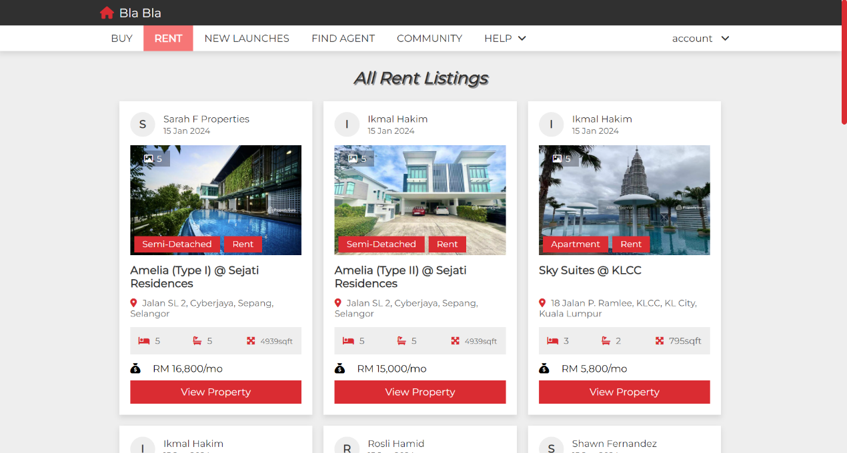

Figure 29. User Rent Page ( Part 1)

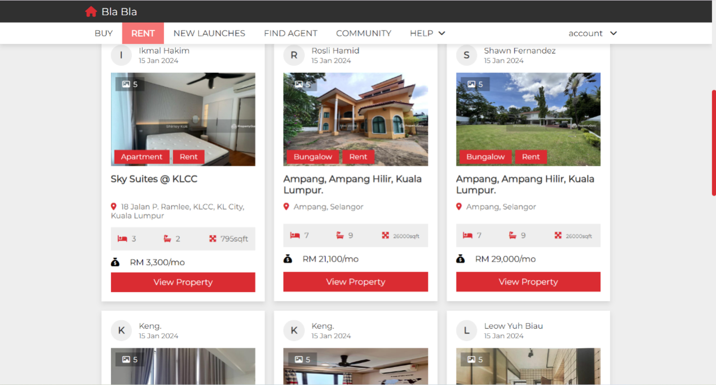

Figure 30. User Rent Page ( Part 2)

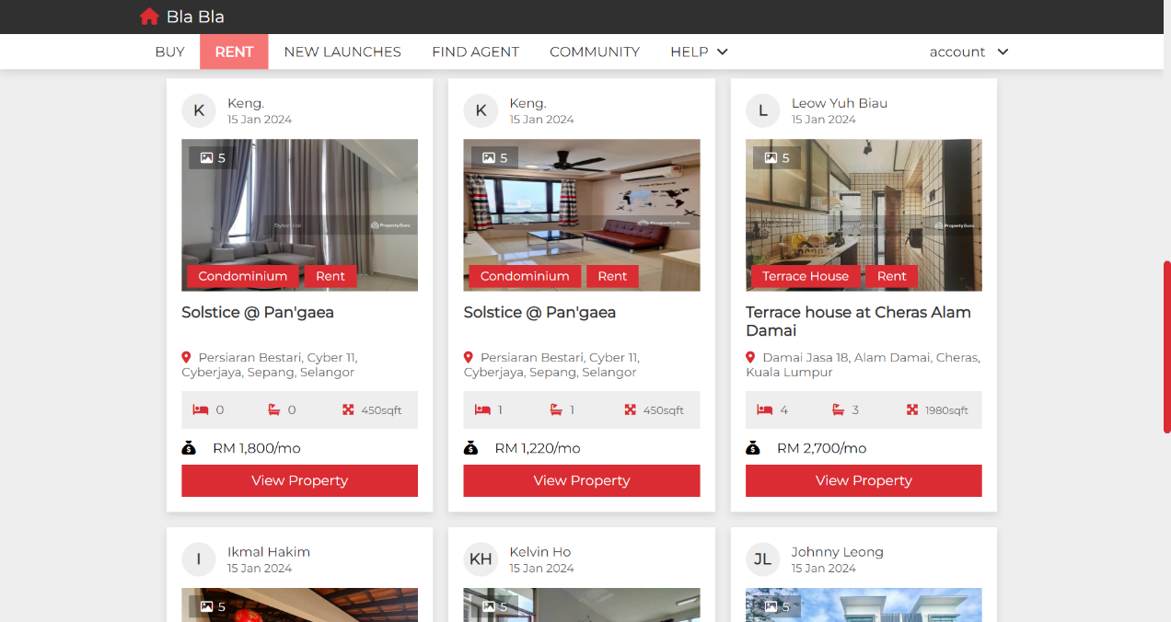

Figure 31. User Rent Page ( Part 3)

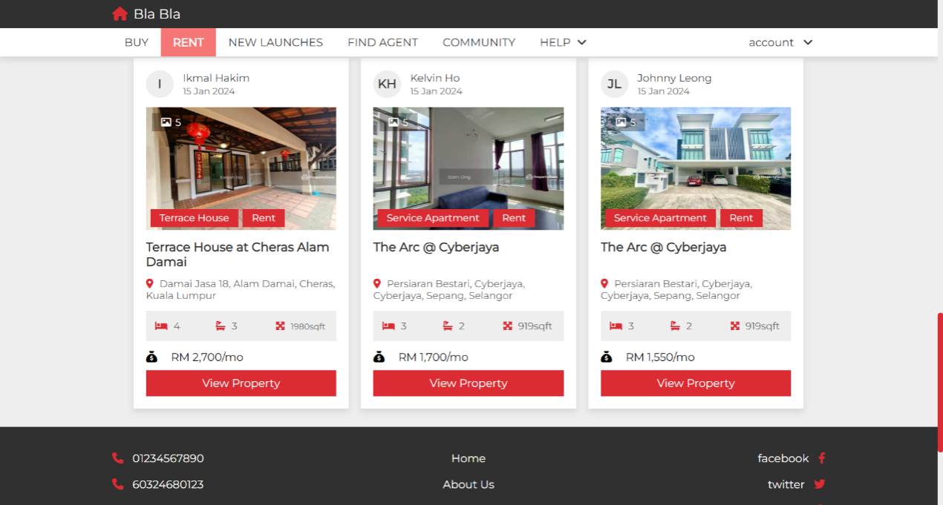

Figure 32. User Rent Page ( Part 4)

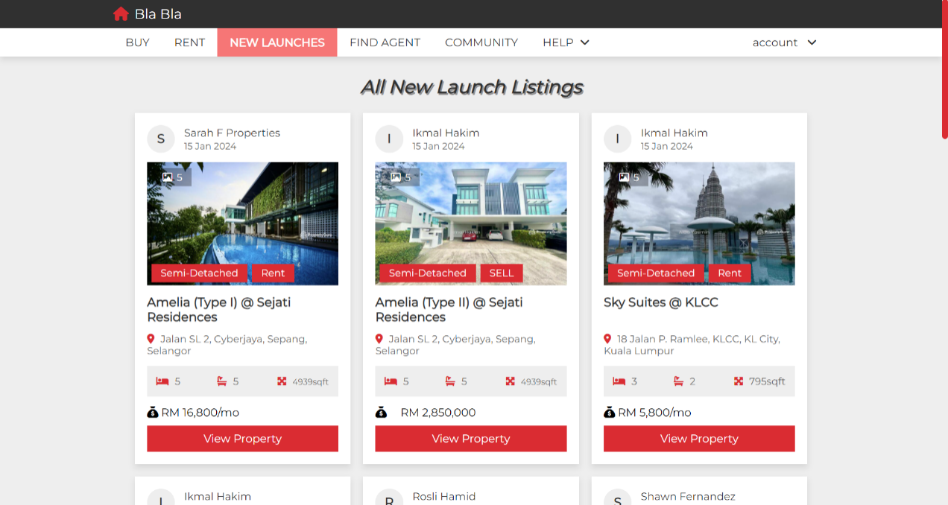

Figure 33. User New Launches Page ( Part 1)

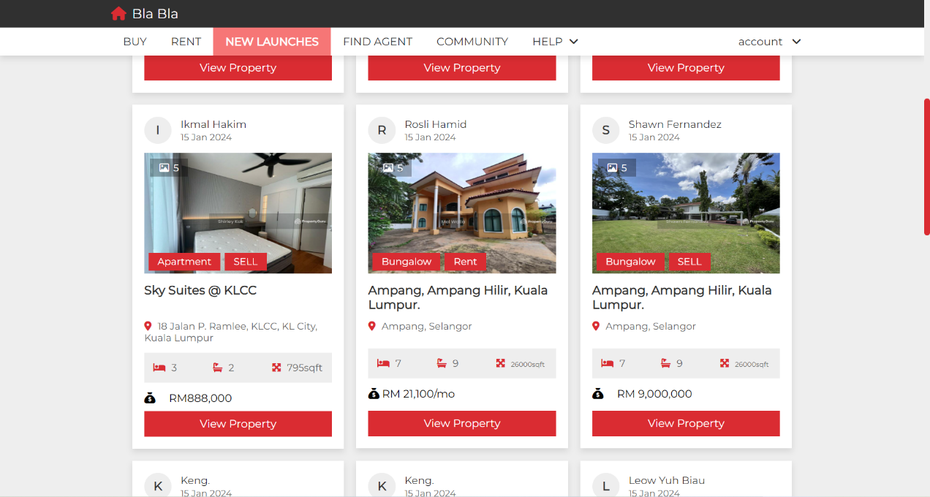

Figure 34. User New Launches Page ( Part 2)

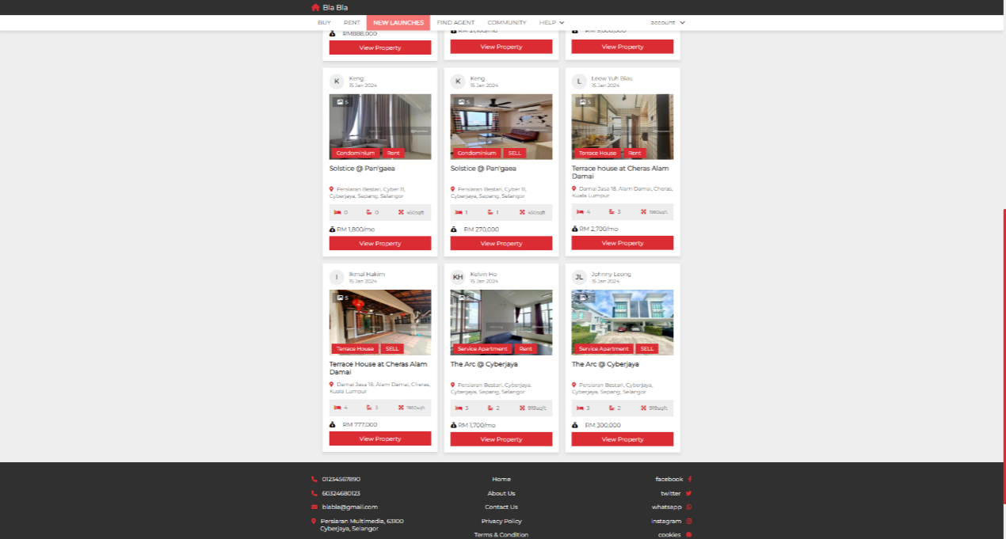

Figure 35. User New Launches Page ( Part 3)

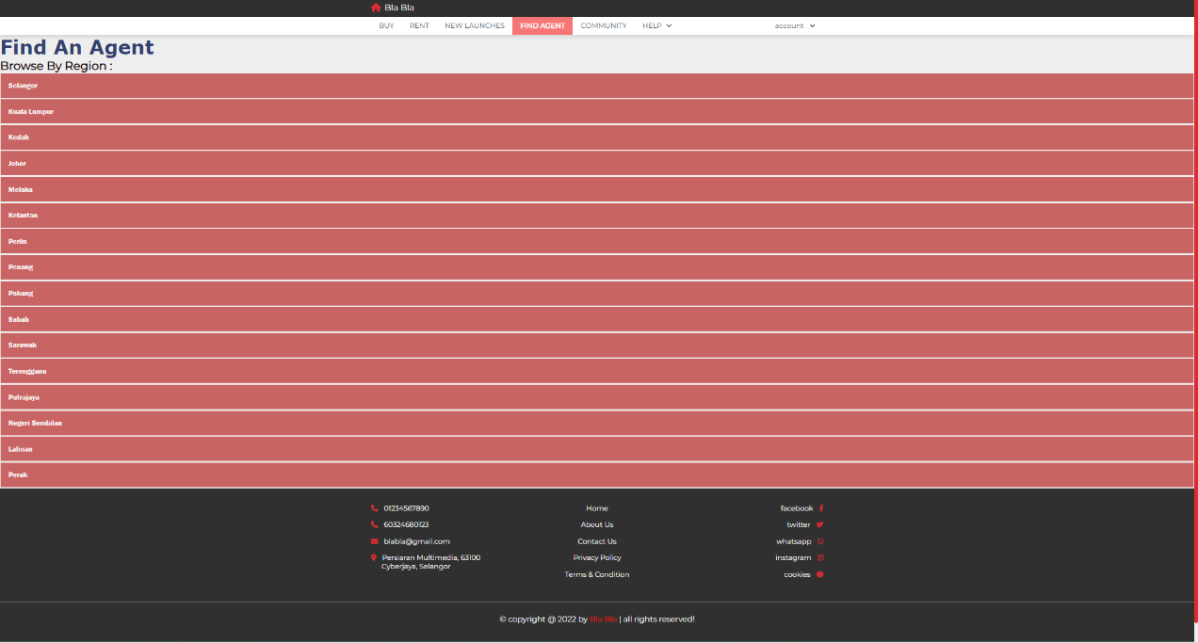

Figure 36. User Find Agent Page (Before Open Collapsible Page)

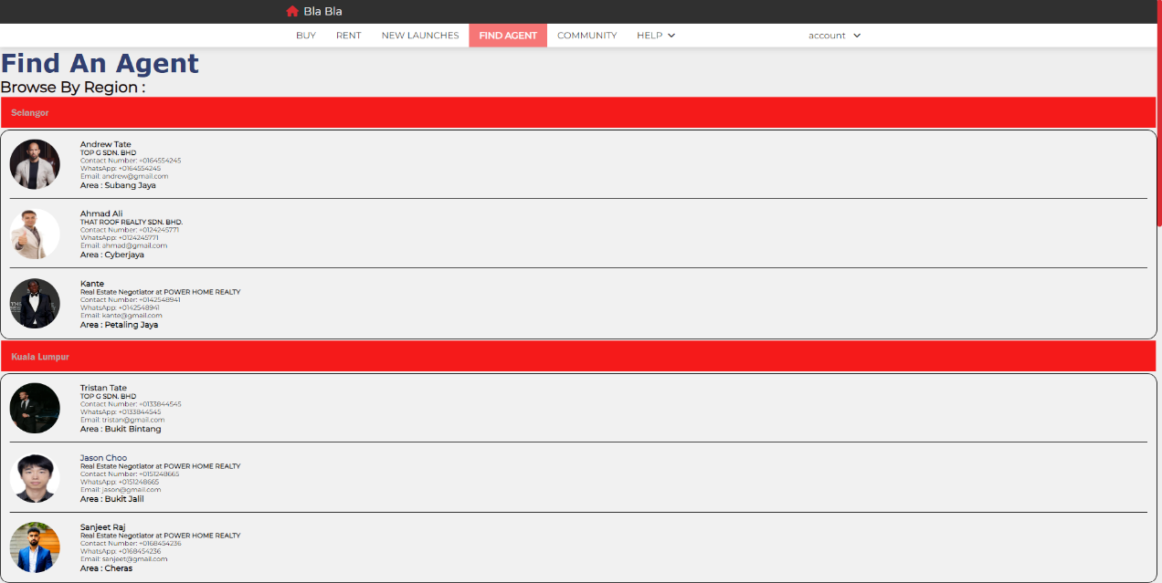

Figure 37. User Find Agent Page (After Open Collapsible Button Part 1)

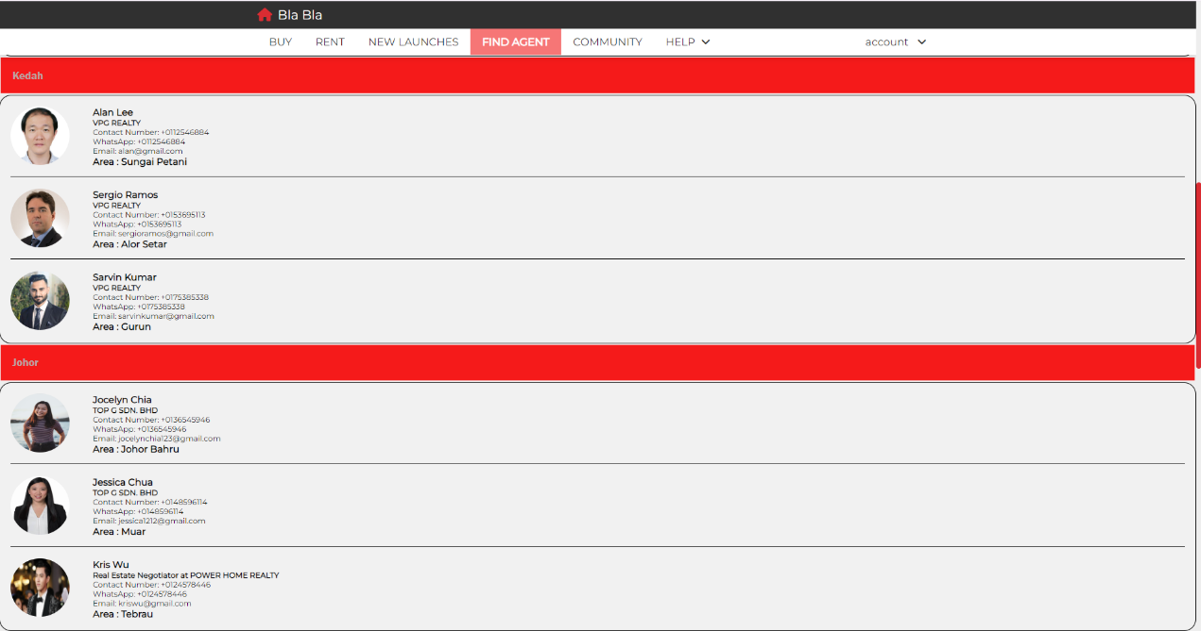

Figure 38. User Find Agent Page (After Open Collapsible Button Part 2)

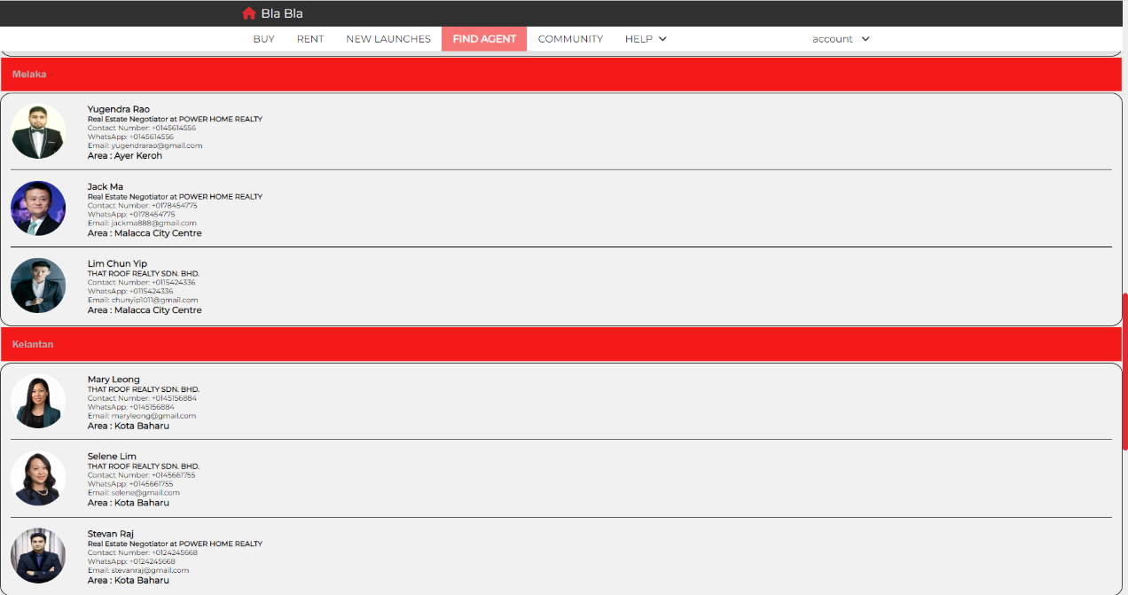

Figure 39. User Find Agent Page (After Open Collapsible Button Part 3)

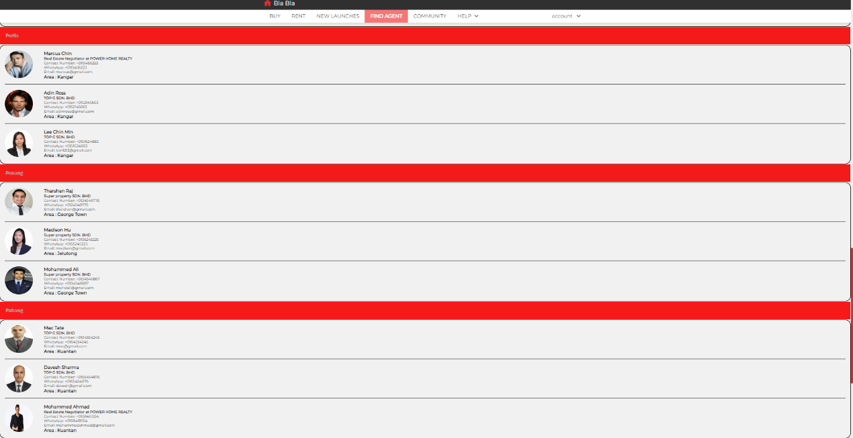

Figure 40. User Find Agent Page (After Open Collapsible Button Part 4)

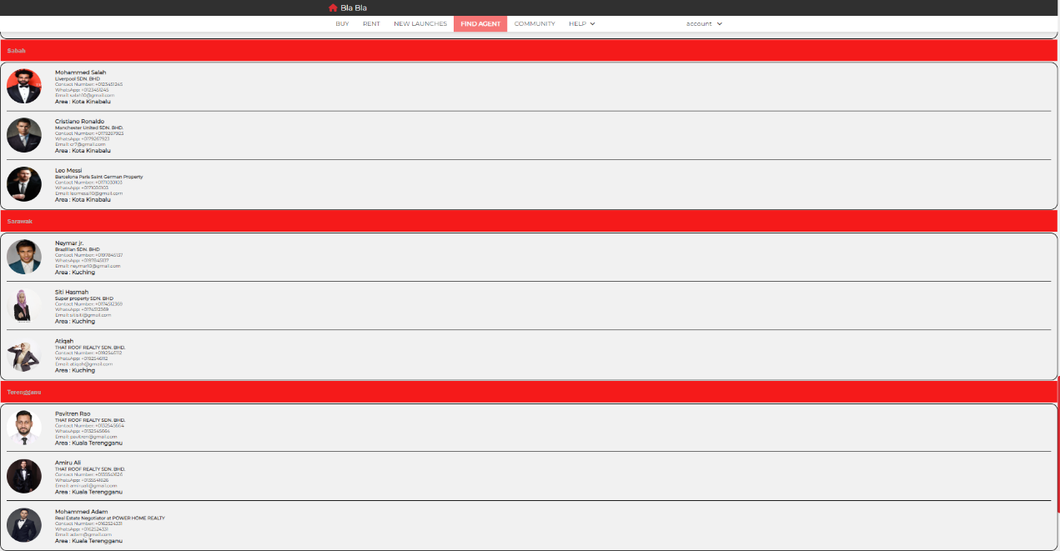

Figure 41. User Find Agent Page (After Open Collapsible Button Part 5)

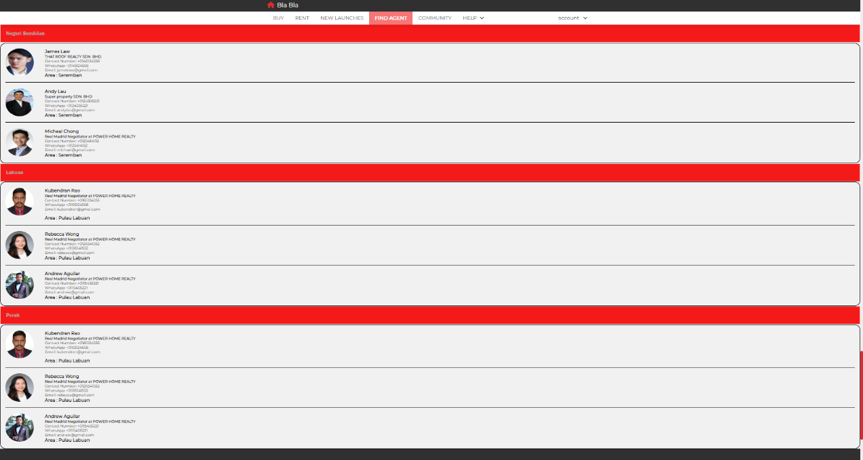

Figure 42. User Find Agent Page (After Open Collapsible Button Part 6)

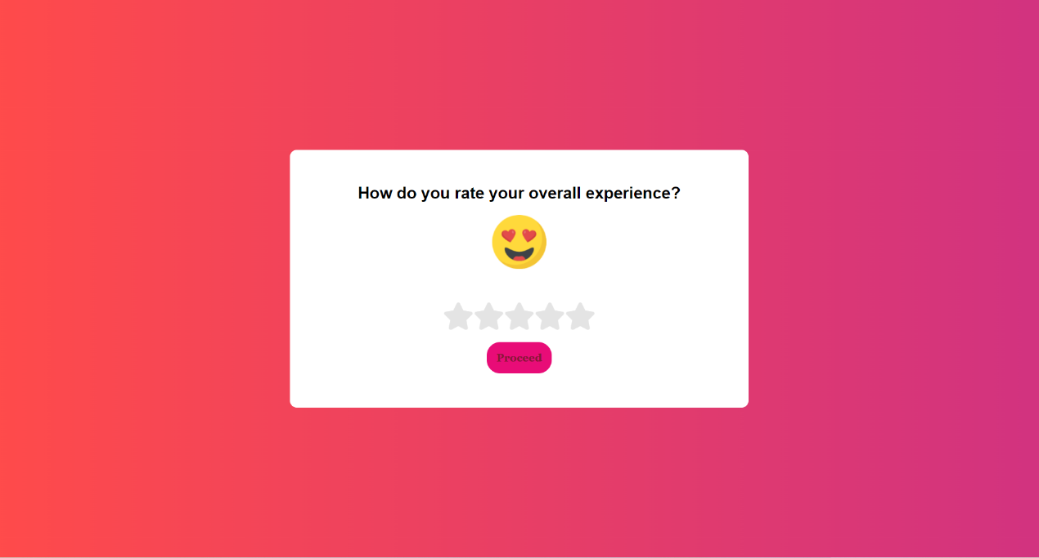

Figure 43. User Rating Page (After clicking feedback on naavigation bar)

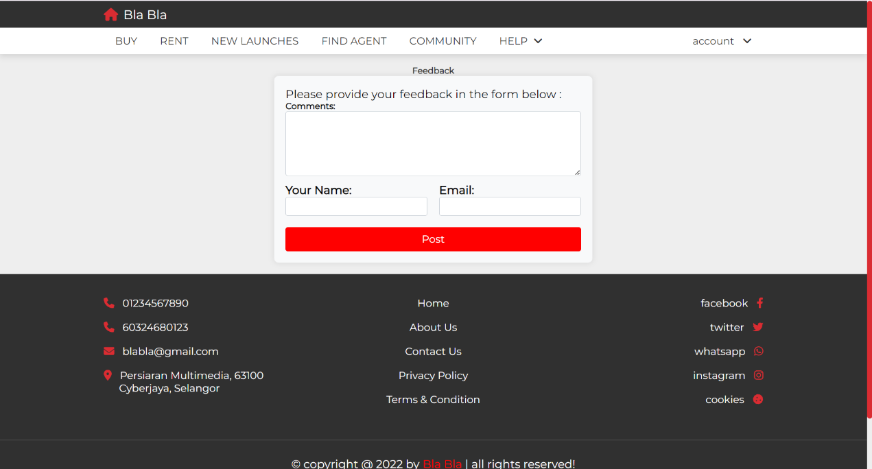

Figure 44. User Feedback Page (After clicking proceed button in Figure 40.)



Figure 45. User Testimonial Page

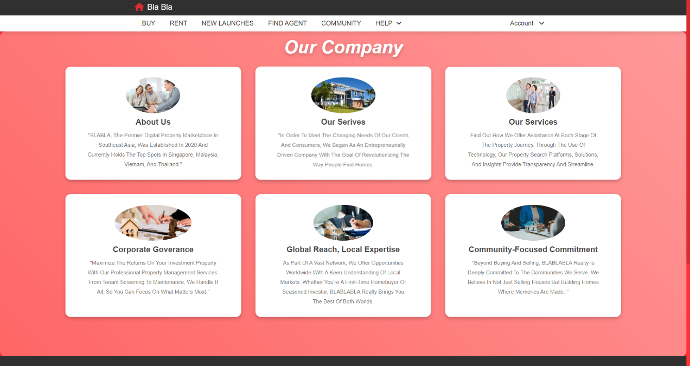

Figure 46. User About Us Page

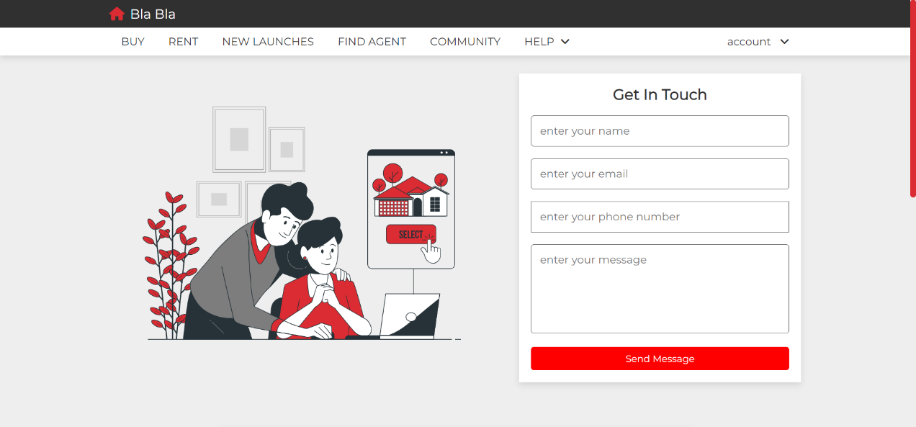

Figure 47. User Contact Us Page (Part 1)

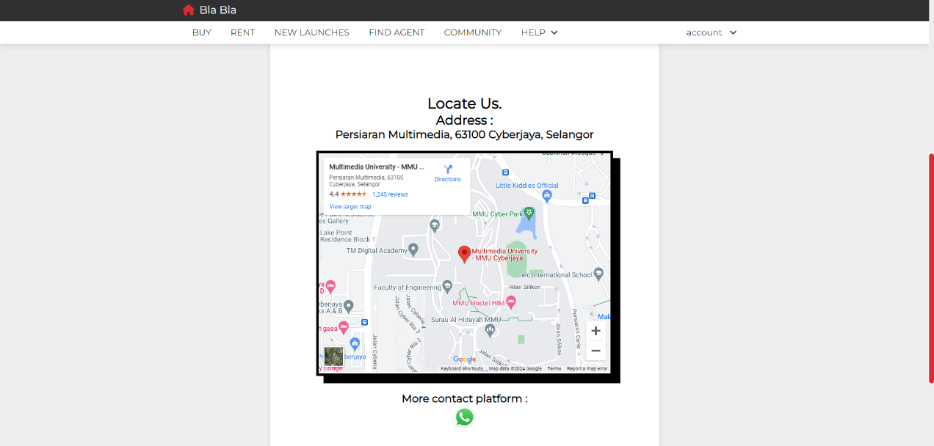

Figure 48. User Contact Us Page (Part 2)

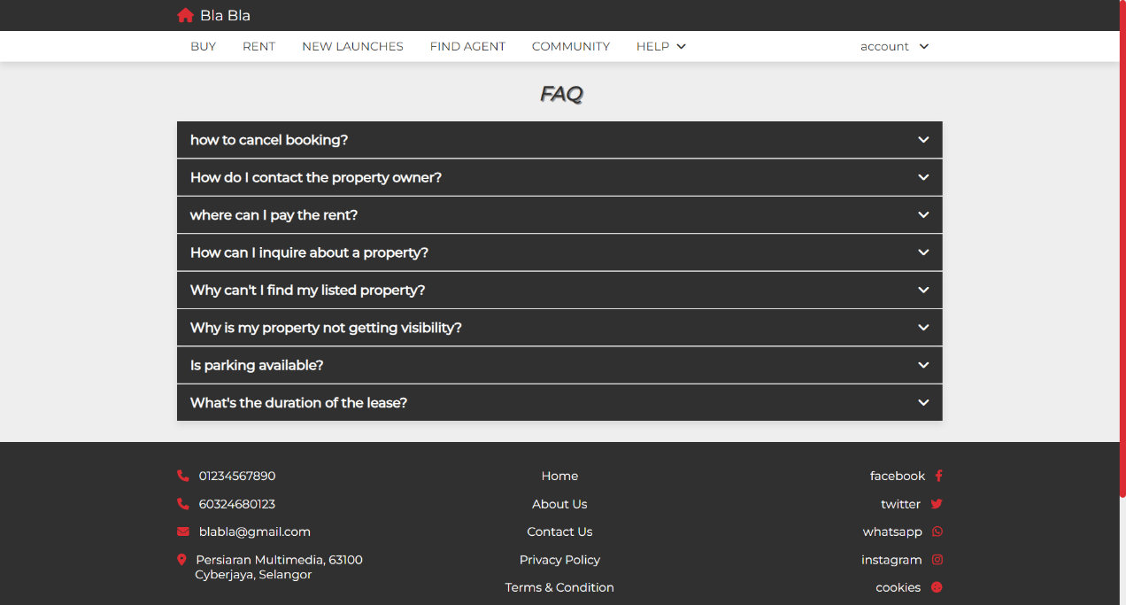

Figure 49. User FAQ Page (Before Open Collapsible Button)

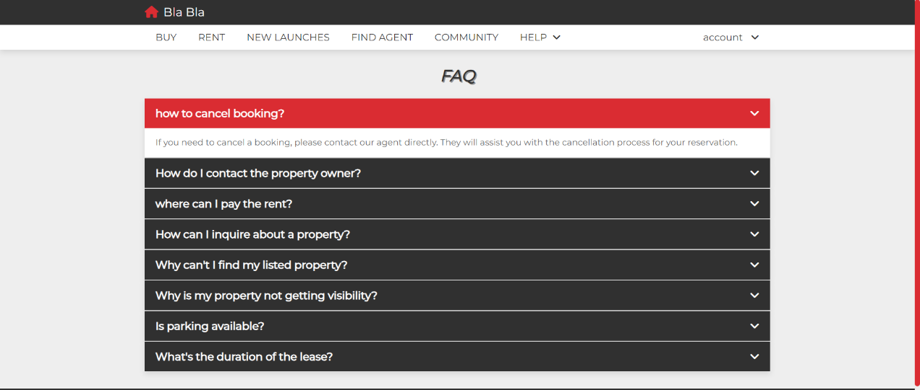

Figure 50. User FAQ Page (After Open Collapsible Button)

**REFERENCES/BIBLIOGRAPHY**

List of URL addresses or reference books

**APPENDIX**

|  |  |
| --- | --- |
| **Meeting No.** | 1 |
| **Project Title** | Property Rental System |
| **Date** | 27 December 2023 |
| **Time** | 8:00 p.m. – 9:00 p.m. |
| **Venue** | Online |

**ATTENDANCE**

|  |  |
| --- | --- |
| **Present** | **Absent** |
| 1. Tan Kim Hian 2. Lim Sai Man 3. Koh Soon Keat 4. Wong Yan Sheng |  |

|  |  |  |
| --- | --- | --- |
| **NO** | **ITEM** | **INFO/ACTION** |
| 1 | * 1. Discuss the dates and time for each meeting to be held.   2. Decision was made that we will be conducting 2nd meeting on 29th December 2023, 3rd meeting on 15th January 2024 and 4th meeting on 22nd January 2024. | All |
| 2 | * 1. Each Group member must find websites related to the project title.   2. All must do research on how to create a Website with CSS and HTML. | All  All |
|  |  |  |
|  |  |  |

The meeting was adjourned at 9:00 p.m.

Prepared by:

Lim Sai Man

|  |  |
| --- | --- |
| **Meeting No.** | 2 |
| **Project Title** | Property Rental System |
| **Date** | 29 December 2023 |
| **Time** | 8:00 p.m. – 9:11 p.m. |
| **Venue** | Online |

**ATTENDANCE**

|  |  |
| --- | --- |
| **Present** | **Absent** |
| 1. Tan Kim Hian 2. Lim Sai Man 3. Koh Soon Keat 4. Wong Yan Sheng |  |

|  |  |  |
| --- | --- | --- |
| **NO** | **ITEM** | **INFO/ACTION** |
| 1 | * 1. All group members try to figure out 20 pages of HTML website pages to meet the criteria of the assignment.   2. After listing out 20 pages, all members are assigned with their pages to be coded. | All  All |
| 2 | * 1. Koh Soon Keat and Tan Kim Hian are responsible for building the User Sided Website.   2. Lim Sai Man is assigned to build the Agent Sided Website.   3. Wong Yan Sheng is assigned to build the Admin Sided Website. | Koh Soon Keat  Tan Kim Hian  Lim Sai Man  Wong Yan Sheng |
| 3 | * 1. A timetable is made to make sure all of us will be able to complete our assigned task before the deadline. | All |
|  |  |  |

The meeting was adjourned at 9:11 p.m.

Prepared by:

Lim Sai Man

|  |  |
| --- | --- |
| **Meeting No.** | 3 |
| **Project Title** | Property Rental System |
| **Date** | 15 January 2024 |
| **Time** | 2:00 p.m. – 4:00 p.m. |
| **Venue** | MMU Cyberjaya Library |

**ATTENDANCE**

|  |  |
| --- | --- |
| **Present** | **Absent** |
| 1. Tan Kim Hian  2. Lim Sai Man  3. Koh Soon Keat  4. Wong Yan Sheng |  |

|  |  |  |
| --- | --- | --- |
| **NO** | **ITEM** | **INFO/ACTION** |
| 1 | * 1. All group members gathered at Library to check on each other progress regarding the assignment.   2. Discussion among Tan Kim Hian and Koh Soon Keat regarding combining their website and style it with similar CSS code for header and footer. | All  Tan Kim Hian  Koh Soon Keat |
| 2 | * 1. All Group Member have created more than 20 pages of blueprint layout of our website. | All |
| 3 | * 1. All Group Member start writing our code and creating our website | All |
|  |  |  |

The meeting was adjourned at 4 p.m.

Prepared by:

Lim Sai Man

|  |  |
| --- | --- |
| **Meeting No.** | 4 |
| **Project Title** | Property Rental System |
| **Date** | 22 January 2024 |
| **Time** | 2:00 p.m. – 4:00 p.m. |
| **Venue** | MMU Cyberjaya Library |

**ATTENDANCE**

|  |  |
| --- | --- |
| **Present** | **Absent** |
| 1. Tan Kim Hian  2. Lim Sai Man  3. Koh Soon Keat  4. Wong Yan Sheng |  |

|  |  |  |
| --- | --- | --- |
| **NO** | **ITEM** | **INFO/ACTION** |
| 1 | * 1. All Group Member combined their code into one functional website.   2. Tan Kim Hian and Koh Soon Keat were responsible for writing the introduction and purpose of the report.   3. All the group member screenshot and upload their images of their website into the report.   4. Lim Sai Man and Wong Yan Sheng were responsible to record the meetings for appendix and references. | All  Tan Kim Hian  Koh Soon Keat  All  Lim Sai Man  Wong Yan Sheng |
| 2 | * 1. All Group Member demonstrated how the website work and recorded it as our presentation. | All |
|  |  |  |
|  |  |  |

The meeting was adjourned at 4 p.m.

Prepared by:

Lim Sai Man